Database Systems Project Part#2

Dat Vo

Victor Abraham

Aayush Goyal

Aman Khoja

**Current ERD and ERD data dictionary and Schema and schema data dictionary with any changes noted in red**

* **ERD**

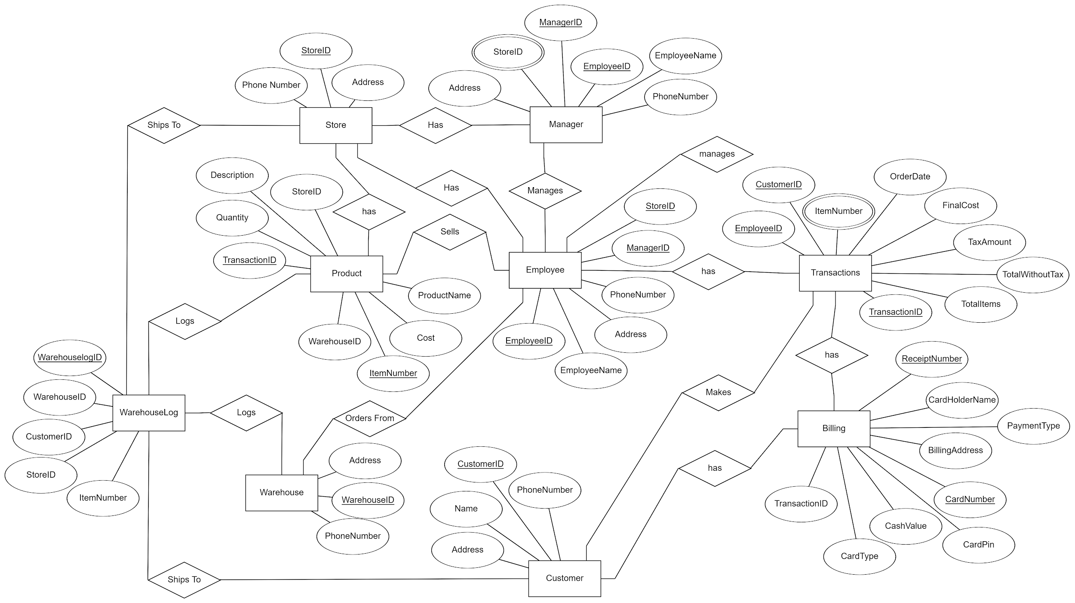

**Schema**

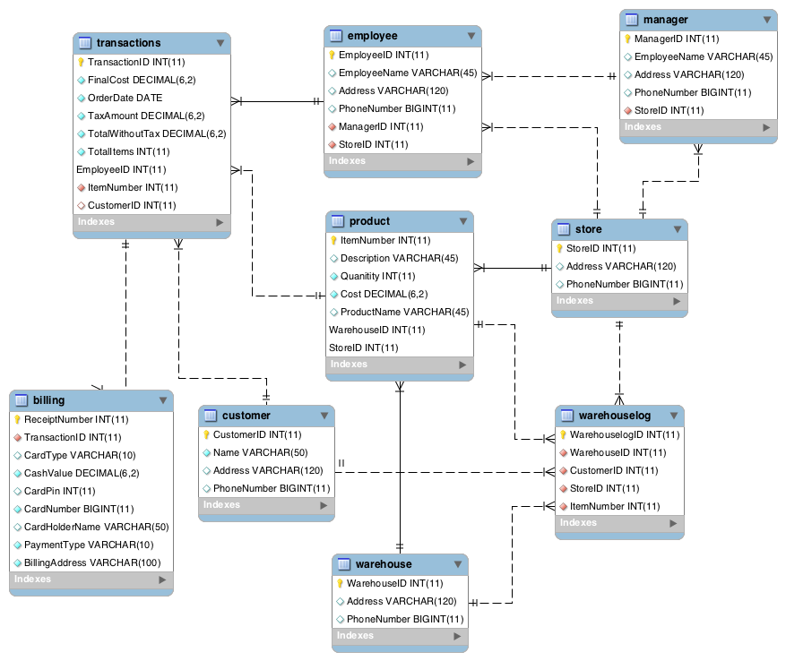

|  |  |  |  |  |  |
| --- | --- | --- | --- | --- | --- |
|  | **Schema Data Dictionary** |  |  |  |  |
| **Table** | **Description** | **Primary Key** | **Super Key** | **Attributes TYPE (DOMAIN)** | **Foreign Key** |
| Warehouse | Describes warehouse info ~~shipping information to customers and stores~~ | WarehouseID | WarehouseID + PhoneNumber | WarehouseID INT (11)  PhoneNumber BIGINT (10)  Address VARCHAR (250)  ~~StoreID INT (11)~~  ~~CustomerID INT (11)~~ | ~~StoreID~~  ~~CustomerID~~ |
| Store | Describes store contact information for warehouse and managers | StoreID | StoreID + PhoneNumber | StoreID INT (11)  PhoneNumber BIGINT (11)  Address VARCHAR (250) | N/A |
| Employee | Describes employee personal information and relation to managers | EmployeeID | EmployeeID + EmployeeName | EmployeeID INT (11)  EmployeeName VARCHAR (45)  PhoneNumber BIGINT (11)  Address VARCHAR (120)  ManagerID INT (11)  StoreID INT (11) | ManagerID  StoreID |
| Billing | Describes billing information for transactions | ReceiptNumber | ReceiptNumber + PaymentType | RecieptNumber INT (11)  ~~PaymentType VARCHAR (50)~~  CardHolderName VARCHAR (100)  CardNumber BIGINT (20)  CardPin SMALLINT (6)  CardType VARCHAR (50)  CashValue INT (11)  BillingAddress VARCHAR (100)  TransactionID INT (11) | TransactionID |
| Manager | Describes manager personal information and employees managed | ManagerID | ManagerID + EmployeeName | ManagerID INT (11)  EmployeeName VARCHAR (100)  PhoneNumber BIGINT (11)  StoreID INT (11)  EmployeeID INT (11)  Address VARCHAR (100) | StoreID  EmployeeID |
| Transactions | Describes cost information for products to customers | TransactionID | TransactionID + OrderDate | TransactionID INT (11)  OrderDate DATE (datetime)  Cost DECIMAL (6,2)  FinalCost DECIMAL (6,2)  TaxAmount DECIMAL (6,2)  TotalWithoutTax DECIMAL (6,2)  TotalItems INT (11)  CustomerID INT (11)  EmployeeID INT (11)  ReceiptNumber INT (11)  ItemNumber INT (11) | CustomerID  EmployeeID  ReceiptNumber  ItemNumber |
| Product | Describes product information and specifications for transactions | ItemNumber | ItemNumber + ProductName | ItemNumber INT (11)  ProductName VARCHAR (100)  Quantity INT (11)  ~~Cost INT (11)~~  Description VARCHAR (100)  WarehouseID INT (11)  StoreID INT (11)  TransactionID INT (11) | WarehouseID  StoreID  TransactionID |
| Customer | Describes customer personal information for transactions | CustomerID | CustomerID + CustomerName | CustomerID INT (11)  CustomerName VARCHAR (100)  Address VARCHAR (250)  PhoneNumber BIGINT (11) | N/A |
| ~~Customer Account~~ | ~~Describes customer account information for customers~~ | ~~AccountID~~ | ~~AccountID + AccountOpenDate~~ | ~~AccountID INT (11)~~  ~~AccountOpenDate DATE (datetime)~~  ~~AccountBalance DECIMAL (6,2)~~  ~~TransactionID INT (11)~~  ~~CustomerID INT (11)~~ | ~~TransactionID~~  ~~CustomerID~~ |
| Warehouselog | Describes warehouse shipping information to customers and stores | WarehouselogID | WarehouselogID + CustomerID | WarehouselogID INT (11)  WarehouseID INT (11)  StoreID INT (11)  CustomerID INT (11)  ItemNumber INT (11) | WarehouseID  StoreID  CustomerID  ItemNumber |

|  |  |  |  |  |
| --- | --- | --- | --- | --- |
|  | **Data Dictionary** |  |  |  |
| **Entity Type** | **Description** | **Keys** | **Relationships** | **Attributes** |
| Warehouse | Warehouse info | WarehouseID (Primary) | Employee orders from Warehouse, Warehouse supplies Product | ~~StoreID~~, Address, WarehouseID, PhoneNumber, ~~CustomerID~~ |
| Warehouselog | Items are shipped to store | WarehouselogID (Primary) | Warehouselog records shipping to Customer, Warehouselog records shipping to Store, Warehouselog records which Warehouse has Product | WarehouselogID, WarehouseID, StoreID, CustomerID, ItemNumber |
| Product | Goods or Services from Sale | ItemNumber (Primary) | Warehouse supplies Product, Store has Products, Employees sell Products | Description, Quantity, TransactionID, StoreID, WarehouseID, ItemNumber, Cost, Product Name |
| Store | Customers purchase Products | StoreID (Primary) | Warehouse ships to Store, Store has Products, Store has Employees, Store has Managers | StoreID, PhoneNumber, Address |
| Employee | Store Worker | EmployeeID (Primary) | Manager manages Employee, Store has Employee, Employee sells Product, Employee has transactions | EmployeeID, EmployeeName, Address, PhoneNumber, ManagerID, StoreID |
| Manager | Manages regular employees | EmployeeID (Primary), StoreID (Foreign) | Store has Manager, Manager manages Employee, ~~Manager manages CustomerAccount~~ | Address, StoreID, ManagerID, EmployeeID, EmployeeName, PhoneNumber |
| ~~Customer Account~~ | ~~Customer's Account Information~~ | ~~CustomerID (Primary)~~ | ~~Manager manages CustomerAccount, Employee manages CustomerAccount, Customer has CustomerAccount~~ | ~~CustomerID, TransactionID, AccountID, AccountBalance, AccountOpenDate~~ |
| Customer | Client purchasing Product | CustomerID (Primary) | Warehouse ships to Customer, Customer makes transactions, Customer has biling, ~~Customer has CustomerAccount~~ | Name, Address, PhoneNumber, CustomerID |
| Biling | Client biling information | ReceiptNumber (Primary) | Customer has biling, Transaction has billing | TransactionID, CardType, CashValue, CardPin, CardNumber, BilingAddress, PaymentType, CardHolderName, ReceiptNumber |

**Screenshot of the Database tool work area**

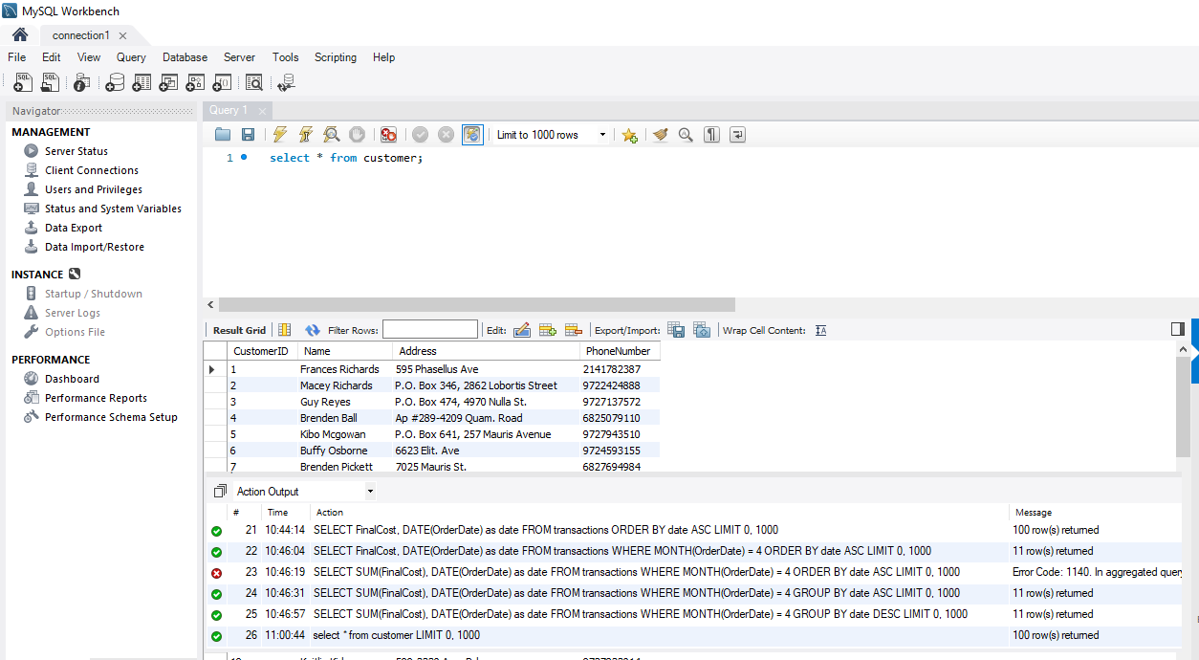

* **CREATE SELECT**

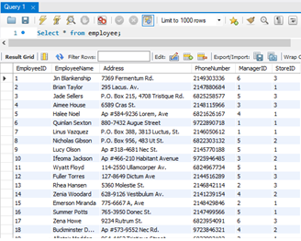

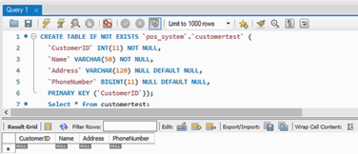

* **INSERT**

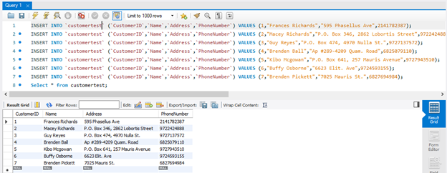

* **DELETE UPDATE**

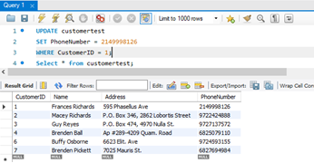

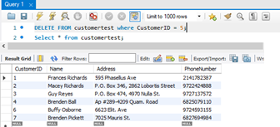

* **DROP**

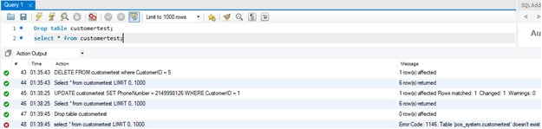

* **Data Generation**

|  |  |
| --- | --- |
| **Table** | **Size** |
| billing | 100 |
| customer | 100 |
| employee | 30 |
| manager | 6 |
| product | 50 |
| store | 3 |
| transactions | 100 |
| warehouse | 3 |
| warehouselog | 100 |

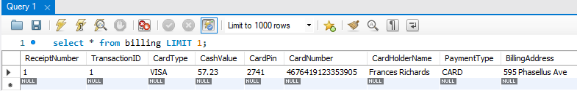

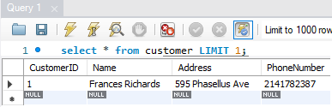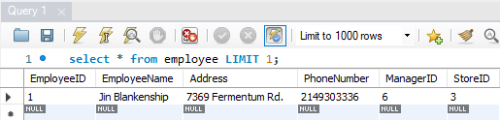

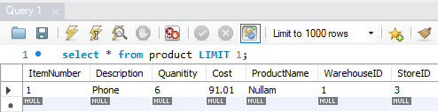

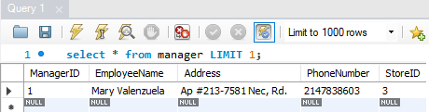

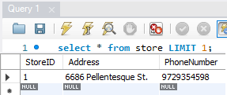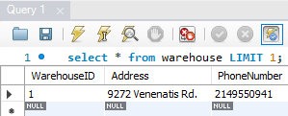

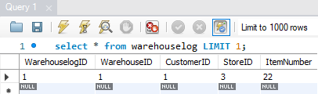

**Query Examples – turn in queries for the following:**

**1. Show a count of the largest population**

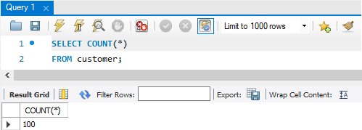

**2. Show a listing of a key entity in the database** 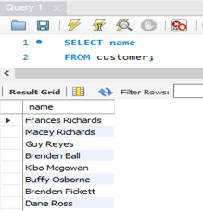

**3. Show a list of entities that must function together 4.Show the cost of an occurrence, derived using aggregate functions**

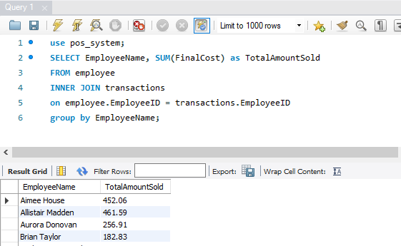

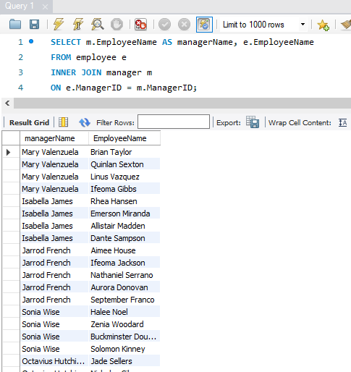

**5. Show a schedule for multiple occurrences, sorted by date and time**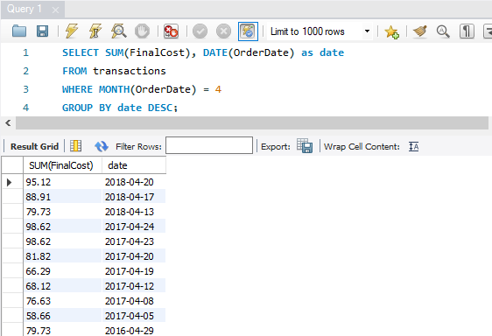

* **Implementation Log**

# TABLE_NAME, CREATE_TIME, UPDATE_TIME

billing, 2019-04-21 22:30:08, 2019-04-22 01:18:46

customer, 2019-04-21 22:09:07, 2019-04-21 22:12:56

employee, 2019-04-21 22:09:07, 2019-04-21 22:12:00

manager, 2019-04-21 22:09:07, 2019-04-21 22:11:00

product, 2019-04-21 22:09:08, 2019-04-21 22:22:26

store, 2019-04-21 22:09:07, 2019-04-21 22:09:32

transactions, 2019-04-21 22:09:08, 2019-04-22 01:18:05

warehouse, 2019-04-21 22:09:08, 2019-04-21 22:19:11

warehouselog, 2019-04-22 02:11:01, 2019-04-22 02:11:01

# TABLE_NAME, COLUMN_NAME, CREATE_TIME

billing, ReceiptNumber, 2019-04-21 22:30:08

billing, TransactionID, 2019-04-21 22:30:08

billing, CardType, 2019-04-21 22:30:08

billing, CashValue, 2019-04-21 22:30:08

billing, CardPin, 2019-04-21 22:30:08

billing, CardNumber, 2019-04-21 22:30:08

billing, CardHolderName, 2019-04-21 22:30:08

billing, PaymentType, 2019-04-21 22:30:08

billing, BillingAddress, 2019-04-21 22:30:08

customer, CustomerID, 2019-04-21 22:09:07

customer, Name, 2019-04-21 22:09:07

customer, Address, 2019-04-21 22:09:07

customer, PhoneNumber, 2019-04-21 22:09:07

employee, EmployeeID, 2019-04-21 22:09:07

employee, EmployeeName, 2019-04-21 22:09:07

employee, Address, 2019-04-21 22:09:07

employee, PhoneNumber, 2019-04-21 22:09:07

employee, ManagerID, 2019-04-21 22:09:07

employee, StoreID, 2019-04-21 22:09:07

manager, ManagerID, 2019-04-21 22:09:07

manager, EmployeeName, 2019-04-21 22:09:07

manager, Address, 2019-04-21 22:09:07

manager, PhoneNumber, 2019-04-21 22:09:07

manager, StoreID, 2019-04-21 22:09:07

product, ItemNumber, 2019-04-21 22:09:08

product, Description, 2019-04-21 22:09:08

product, Quanitity, 2019-04-21 22:09:08

product, Cost, 2019-04-21 22:09:08

product, ProductName, 2019-04-21 22:09:08

product, WarehouseID, 2019-04-21 22:09:08

product, StoreID, 2019-04-21 22:09:08

store, StoreID, 2019-04-21 22:09:07

store, Address, 2019-04-21 22:09:07

store, PhoneNumber, 2019-04-21 22:09:07

transactions, TransactionID, 2019-04-21 22:09:0

transactions, FinalCost, 2019-04-21 22:09:0

transactions, OrderDate, 2019-04-21 22:09:0

transactions, TaxAmount, 2019-04-21 22:09:0

transactions, TotalWithoutTax, 2019-04-21 22:09:0

transactions, TotalItems, 2019-04-21 22:09:0

transactions, EmployeeID, 2019-04-21 22:09:0

transactions, ItemNumber, 2019-04-21 22:09:0

transactions, CustomerID, 2019-04-21 22:09:0

warehouse, WarehouseID, 2019-04-21 22:09:08

warehouse, Address, 2019-04-21 22:09:08

warehouse, PhoneNumber, 2019-04-21 22:09:08

warehouselog, WarehouselogID, 2019-04-22 02:11:01

warehouselog, WarehouseID, 2019-04-22 02:11:01

warehouselog, CustomerID, 2019-04-22 02:11:01

warehouselog, StoreID, 2019-04-22 02:11:01

warehouselog, ItemNumber, 2019-04-22 02:11:01